**YipYap**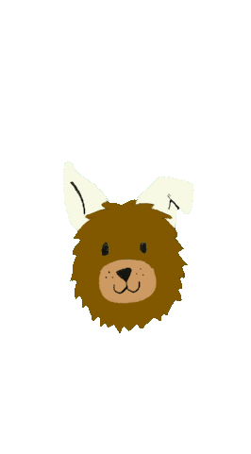

**Statement of Work**

Erin Dorsey

* Helped map backend of app
* Helped script and acted in video
* Organized and wrote project documentation, timeline, statement of work, and project architecture
* Wrote README for Github

Laura Joy Erb

* Helped plan general architecture of app (functions and layout)
* Work on graphical user interface design for app, specifically the feed page
* Helped script and acted in video
* Programmatically connected all activities and screens (interface designer)
* GitHub coordinator and resident expert

Mohammed Uddin

* Led backend development of the app
* Researched Google Firebase to store and retrieve data
* Utilized various libraries (Piccaso, Picture Cropping) to aid app functionality
* Along with Laura Joy, worked through the debugging phase
* Wrote Software Architecture PowerPoint (backend)
* Helped script, shoot, and act in video

Erin Thomas

* Planned general architecture of app (functions and layout)
* Worked on graphical user interface design for app, specifically the home page and post picture page
* Made video; advertised marketability
* Helped make script; acted in video
* Worked on project documentation (commenting code)

Genny Norman

* Created digital logo
* Helped with project documentation
* Acted in video
* Helped with adding features to the Post class to implement like button